ISL9237
Software Installation Guide

Chetna Tailor
Rev 1.0 CT042815

Table of Contents
Introduction 4
1 Getting Started 4
1.1 Required Hardware 4
1.2 Required software 4
1.3 Installing GUI 4
1.4 Installing USB Drivers 5
2 Using the GUI 9
2.1 Setting USB connection 9
2.2 Getting Started 9

Table of Figures

Figure 1: ISL9237 Installation Wizard 4
Figure 2: ISL9237 Control Software Installer 5
Figure 3: Device Manager with before drivers are installed 6
Figure 4: Update Driver 6
Figure 5: Search USB Drivers Manually 7
Figure 6: Search USB Drivers Manually 7
Figure 7: Navigate to “USB-I2C Drivers” Folder 8
Figure 8: Install Digitally Signed Drivers 8
Figure 9: Drivers successfully installed 9
Figure 10: ISL9237 Graphical User Interface 10

- Introduction
The ISL9237 Control Software communicates with ISL9237 controller via USB to on board SMBus interface. The Graphical User Interface (GUI) facilitates access to ISL9237 SMBus Registers.

- Getting Started
This section describes how to install, start and use the GUI software.
  - Required Hardware
ISL9237 Evaluation Board
USB 2.0 A/B cable
  - Required software
ISL9237 Control installation CD or zip files
The CD and zip files include ISL9237 Control Software, National Instruments Runtime Engine and USB interface module driver.
  - Installing GUI
Both the ISL9237 Control Software and the National Instruments Runtime Engine are installed automatically from the installation wizard.
Note: It is recommended to close all other applications before this installation and to reboot the computer
when the installation is completed.
- Insert the LabVIEW installation CD and run the “Autorun.Exe”.
Note: From the zip file, unzip the ISL9237 SMBus Tool.zip and extract to folder ISL9237 Control. Run the
“AutoRun.Exe”.
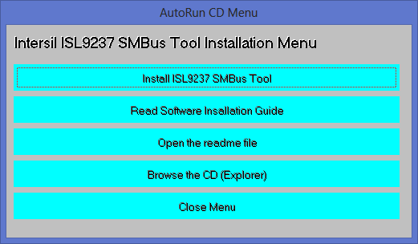
Figure 1: ISL9237 Installation Wizard

- Press “Install ISL9237 Control Software” and the following menu will appear. Press “Next”
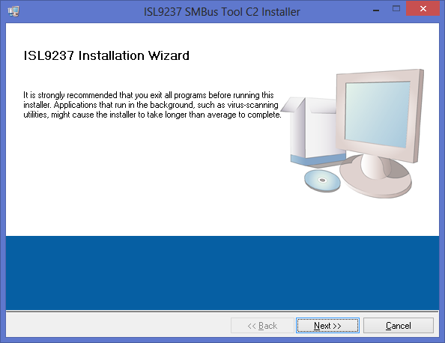
Figure 2: ISL9237 Control Software Installer

- Follow the instruction to accept two End User License Agreements to complete the software installation.
- Press “Close Menu” from installation wizard.
  - Installing USB Drivers
After GUI installation, connect the ISL9237 evaluation board to the USB port of your PC.

When Window detects new hardware, the new hardware wizard should appear. Direct it to look for the driver information file in the “USB drivers” folder (extracted from the downloaded file).

Navigate to installation wizard to locate USB-I2C-W8.inf file for Vista, Window 7 and Window8.
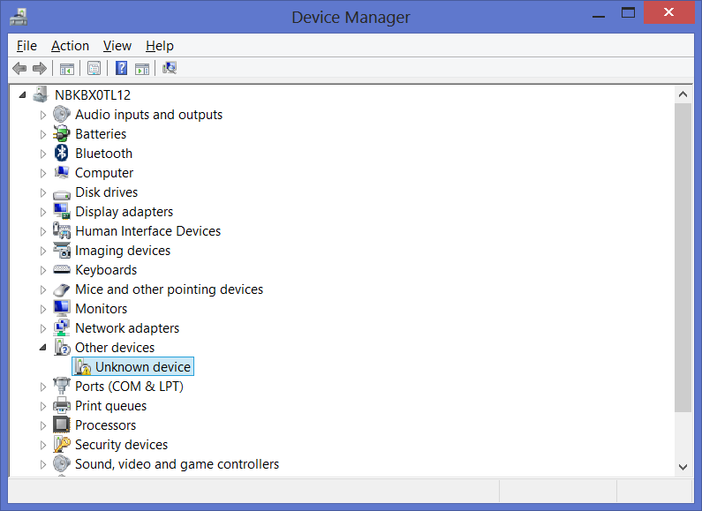

Double Click on “Unknown Device”
Figure 3: Device Manager with before drivers are installed
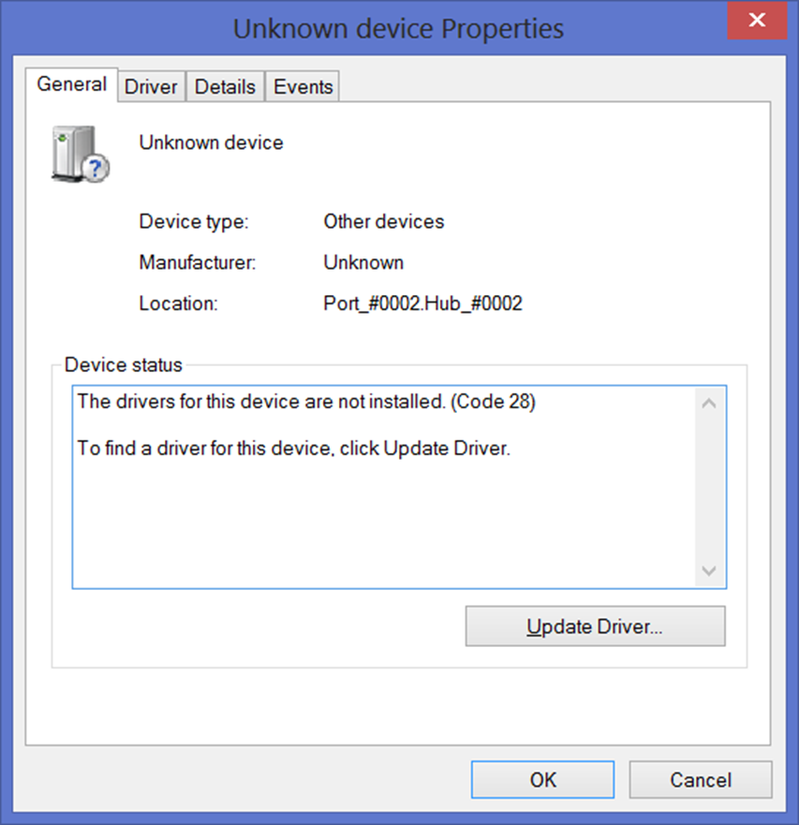

Figure 4: Update Driver

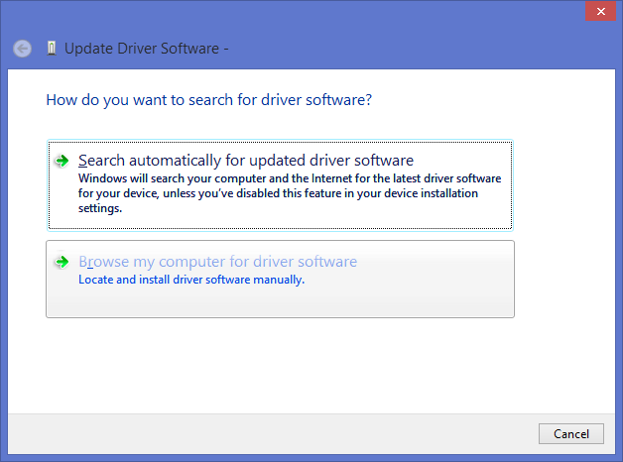
Figure 5: Search USB Drivers Manually

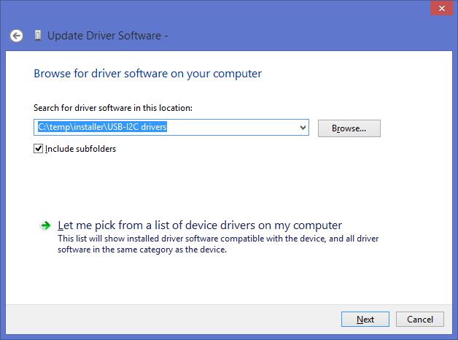
Figure 6: Search USB Drivers Manually

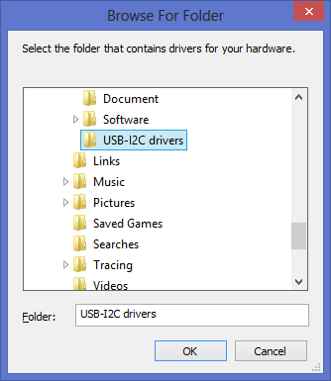
Figure 7: Navigate to “USB-I2C Drivers” Folder

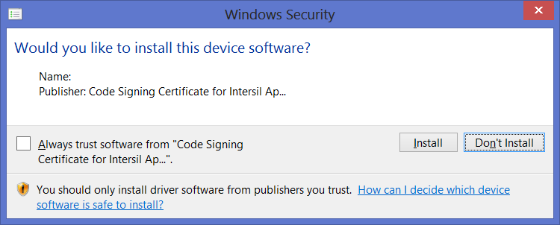
Figure 8: Install Digitally Signed Drivers

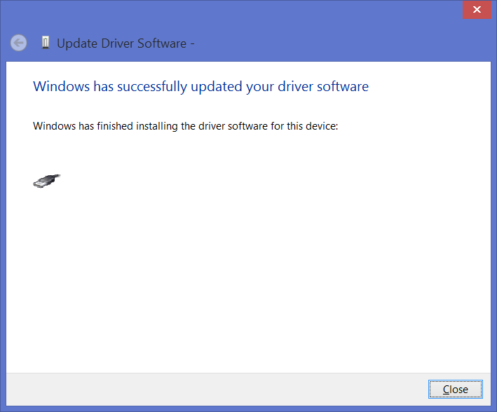
Figure 9: Drivers successfully installed

- Using the GUI
To use the evaluation system, the ISL9237 SMBus Tool Software must be first installed. Do not connect the Evaluation board to the USB port until installation is completed.

The ISL9237 evaluation board must be set up before using the Graphical User Interface (GUI) of the software. Refer to ISL9237 Demo Board User Manual for setup procedures.
  - Setting USB connection
Connect the USB cable from computer’s USB port to ISL9237 Eval board.
  - Getting Started
To start the GUI, select Start -> All Programs -> Intersil -> ISL9237 SMBus Tool
The following GUI will appear as shown in the Figure 8.
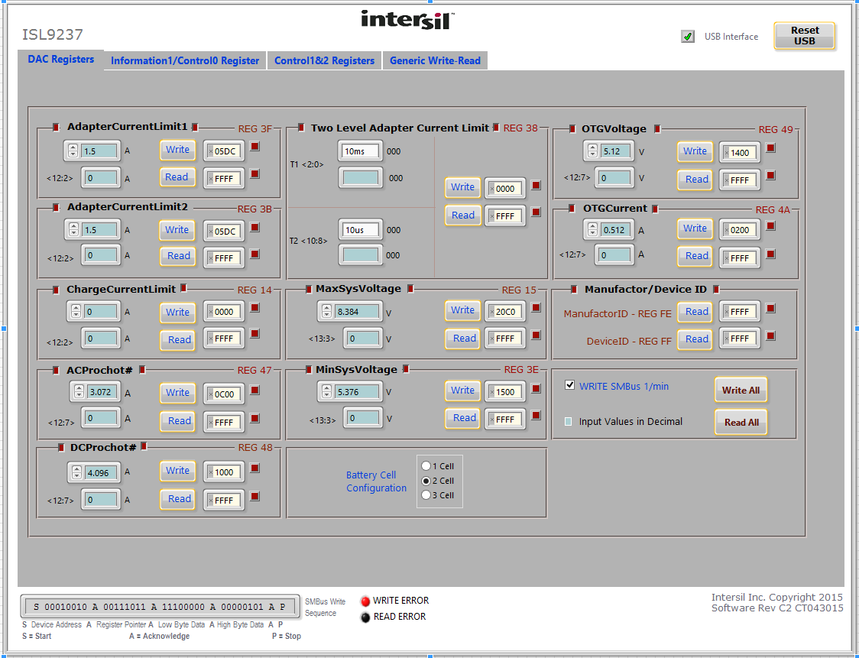
Figure 10: ISL9237 Graphical User Interface

Check the status of the USB interface at the top of the GUI. If the USB communication is OK, the USB Interface Status will show green check mark, as shown in Fig.10.
If the status shows red crossing mark, it indicates that the computer can’t establish the connection. Please follow these steps to trouble shoot:

- Please make sure the driver file for the USB interface is installed correctly. The driver files are on the “USB-I2C Driver” folder in CDROM with the ISL9237 GUI.

- Check the USB Cable connections from the evaluation board to the USB port of the computer.

- Try different sequences: plug in the evaluation board first or start the GUI first.

If the problem continues, it may indicate that the USB drivers are not properly installed; therefore, the eval board is not recognized. Please refer back to Sec 1.4 Installing USB Drivers for this device.

